July 2019 South Bay Montessori Summer Program:
(Preschool)
Biomes Around the World

 | Monday | Tuesday | Wednesday | Thursday | Friday
America the Beautiful | 1  What is Independence Day? | 2  Lincoln  Memorial | 3  Mount Rushmore | 4  School  Closed  Happy 4th! | 5  Washington Monument  Pizza Fridays!
Desert | 8  Gibson Desert | 9  Flora & Fauna of the Desert | 10  In House  Field Trip:  Reptile Show | 11  Snake Edible Craft | 12  Splash Day  Pizza Fridays! | 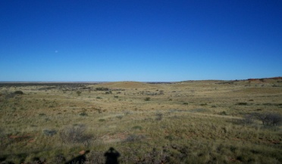
Rainforest | 15  Amazon Rainforest | 16  Flora & Fauna of the Rainforest | 17  Palm tree  Edible Craft | 18  In House  Field Trip:  Environmental Nature Center | 19  Splash Day  Pizza Fridays! | 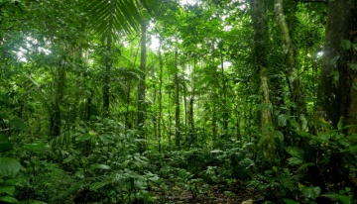
Wetlands | 22  Wetlands of Europe | 23  Flora & Fauna of the Wetlands | 24  In House  Field Trip:  Bubble mania | 25  Green Frog  Edible Craft | 26  Splash Day  Pizza Fridays! | 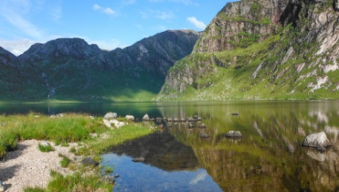
Grassland | 29  Pampas  Argentina  Grassland | 30  Flora & Fauna of the Pampass | 31  Giraffe Edible Craft | August 1  Field Trip:  Lomita Railroad Museum | August 2  Splash Day  Pizza Fridays! | 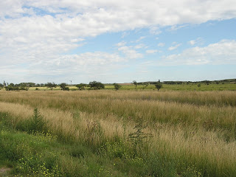

*Field trip dates are subject to change with a 2 week notice
*Field trips will be announced 2 weeks in advance

August 2019 South Bay Montessori Summer Program:
(Preschool)
Biomes Around the World

 | Monday | Tuesday | Wednesday | Thursday | Friday
Savanna | 5  African Savanna | 6  Flora & Fauna of the Savanna | 7  In House  Field Trip:  Ranger Jack | 8  Lion Edible Craft | 9  Splash Day  Pizza Fridays! | 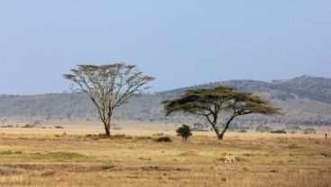
Temperate  Forest | 12  Temperate Forest of North America | 13  Flora & Fauna of the Temperate Forest | 14  Fox  Edible Craft | 15  Field Trip:  Aquarium of the Pacific | 16  Splash Day  Pizza Fridays! | 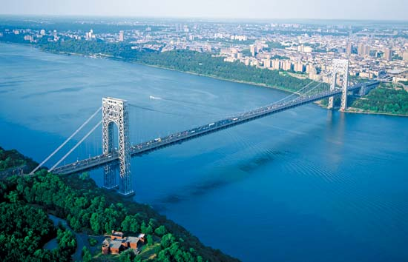
Tundra | 19  Arctic Tundra | 20  Flora & Fauna of the Tundra | 21  In House  Field Trip: Magic Show | 22  Polar Bear  Edible Craft | 23  Splash Day  Pizza Fridays! | 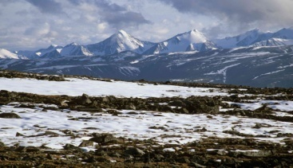
End of Summer Fun! | 26  Puzzle Day | 27  Board  Games | 28  Share a Book  Day | 29  School Closed In-Service Day | 30  School Closed  In-Service Day
First Week of School | September 2  No School  Labor Day | September 3  First Day of School

*Field trip dates are subject to change with a 2 week notice
*Field trips will be announced 2 weeks in advance

