South Bay Montessori School
July 2019 Summer Program Kindergarten/ 1st Grade
Scientists and Inventions
 | Monday | Tuesday | Wednesday | Thursday | Friday
America the Beautiful | 1  What is Independence Day? | 2  Washington Memorial | 3  White House | 4  School Closed  Happy 4th!!! | 5  Jefferson  Memorial  Pizza Fridays!
Ancient Inventions | 8  The Wheel | 9  Hieroglyphics | 10  In House  Field Trip:  Reptile Show | 11  Egyptian Sailing Ship | 12  Dark Ages  Splash Day  Pizza Fridays! | 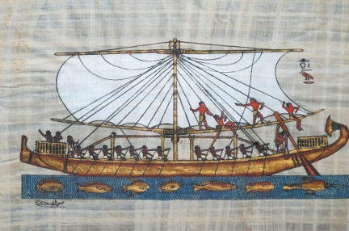
500 B.C. to  200 B.C. | 15  Pythagoras | 16  Aristotle | 17  Archimedes | 18  In House  Field Trip:  Environmental Nature Center | 19  Science Experiments  Splash Day  Pizza Fridays! | 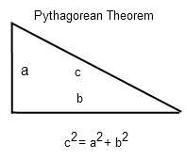
1st Century A.D. | 22  Strabo | 23  Hero of Alexandria | 24  In House  Field Trip:  Bubble mania | 25  Simple Machines | 26  Splash Day  Pizza Fridays! | 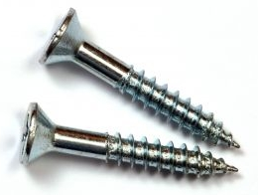
1455-1600s | 29  Johann Guttenburg | 30  Leonardo Da Vinci  Da Vinci Bridge | 31  Copernicus | August 1  Field Trip:  Lomita Railroad Museum | August 2  Galileo  Splash Day  Pizza Fridays! | 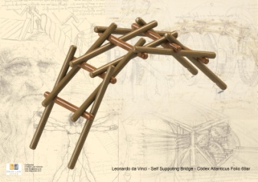

*Field trip dates are subject to change with a 2 week notice
*Field trips will be announced 2 weeks in advance

South Bay Montessori School
August 2019 Summer Program Kindergarten/ 1st Grade
Scientists and Inventions

 | Monday | Tuesday | Wednesday | Thursday | Friday
1600s-1700s | 5  Blaise Pascal | 6  Issac Newton | 7  In House  Field Trip:  Ranger Jack | 8  Benjamin Franklin | 9  Benjamin Franklin  Biography  Splash Day  Pizza Fridays! | 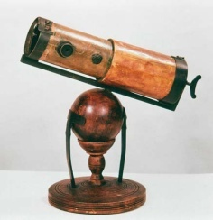
1700s-1900s | 12  Edward Jenner | 13  Thomas Edison | 14  Alexander Graham Bell | 15  Field Trip:  Aquarium of the Pacific | 16  Splash Day  Pizza Fridays! | 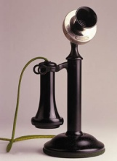
1900s-Present | 19  The Wright Brothers | 20  Albert Einstein | 21  In House  Field Trip:  Magic Show | 22  Marie Curie | 23  My Favorite Modern Scientist  Pizza Fridays! | 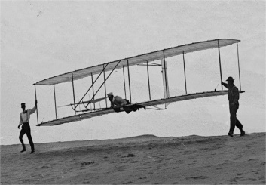
End of Summer | 26  Puzzle Day | 27  Board  Games | 28  Share a Book  Day | 29  School Closed In-Service Day | 30  School Closed  In-Service Day
First Week of School | September 2  No School  Labor Day | September 3  First Day of School
*Field trip dates are subject to change with a 2 week notice
*Field trips will be announced 2 weeks in advance

